Airline Management System

**Group Members:**

* Ahmad Mustafa BSCE21023
* Awwab Samad BSCE21002
* Syed Afraz Tahir BSCE21024

**Features:**

**User Features:**

1. User login system
2. Home page
3. Search flight
4. Book a flight
5. Get ticket
6. Update booking & Get new ticket

**Admin Features:**

1. View flights & Sorting filters
2. Add a flight
3. Update flight
4. Delete flight
5. View booking & Sorting Filters

**A) User Login:**

1. **Create account:**

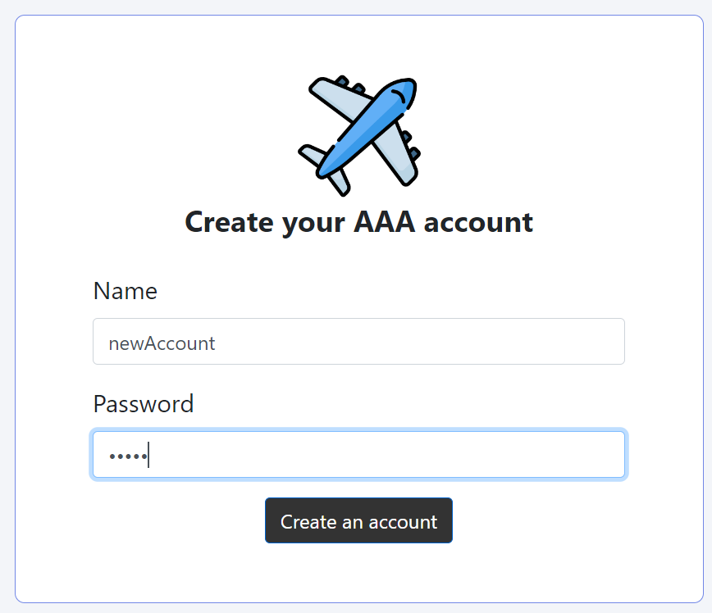

Enter a name and password

1. **Login:**

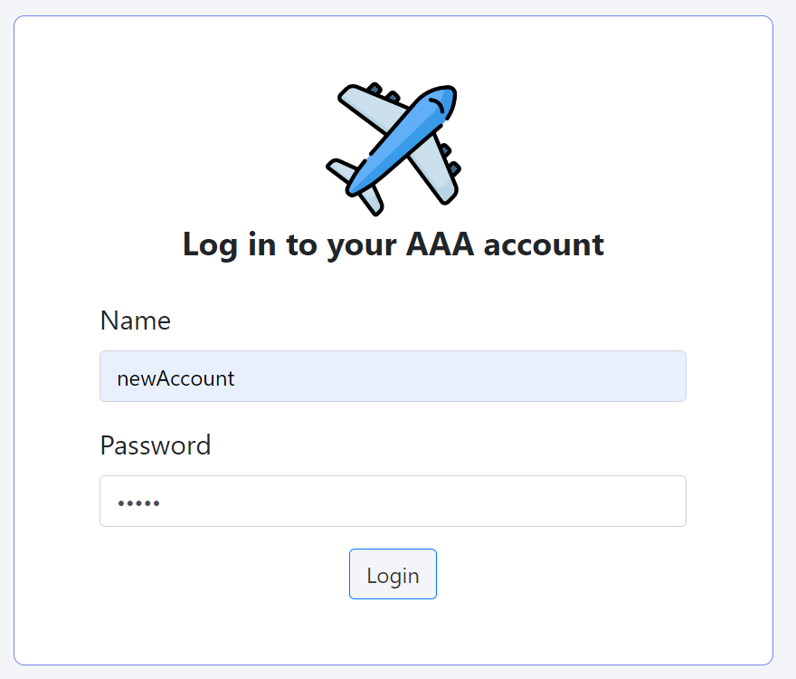

Login if account is already made.

**B) Booking a flight:**

**1. Enter flight details:**

* Select a origin and destination city
* Enter your departure date and day
* Enter travel class (economy or business)
* Find your flight

**2. Select which flight to book:**

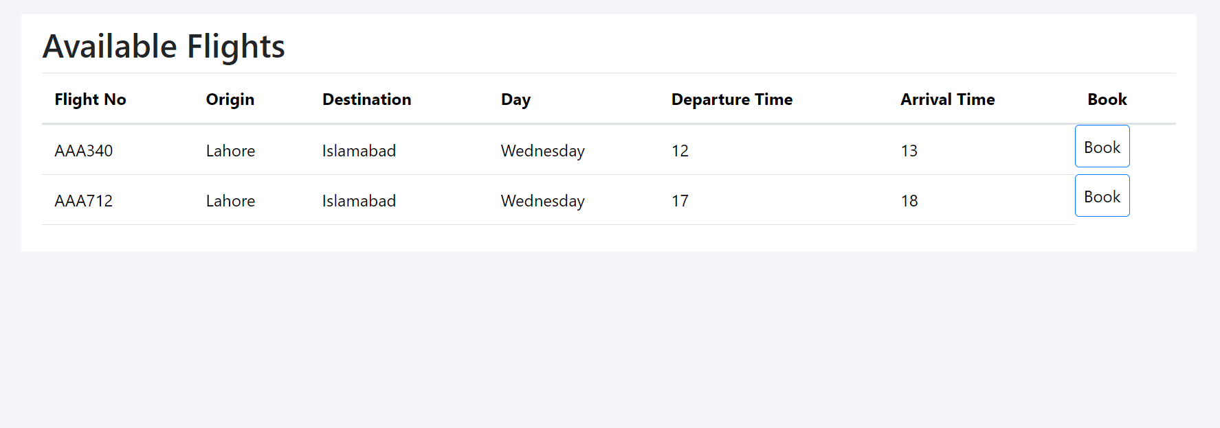

Select a flight to book (if available)

1. **Enter Passenger Details:**

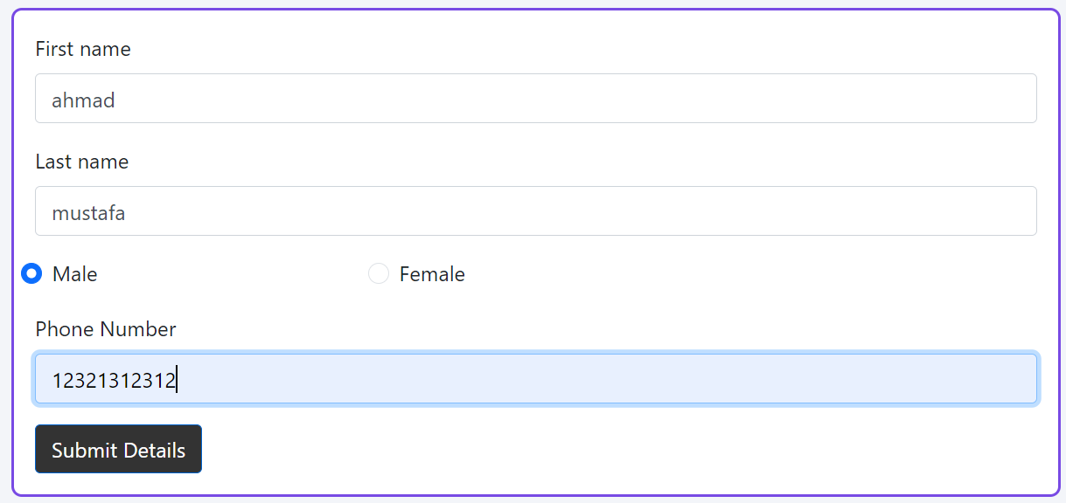

Enter the passenger details accordingly.

1. **Payment:**

Enter credit card details.

1. **Ticket:**

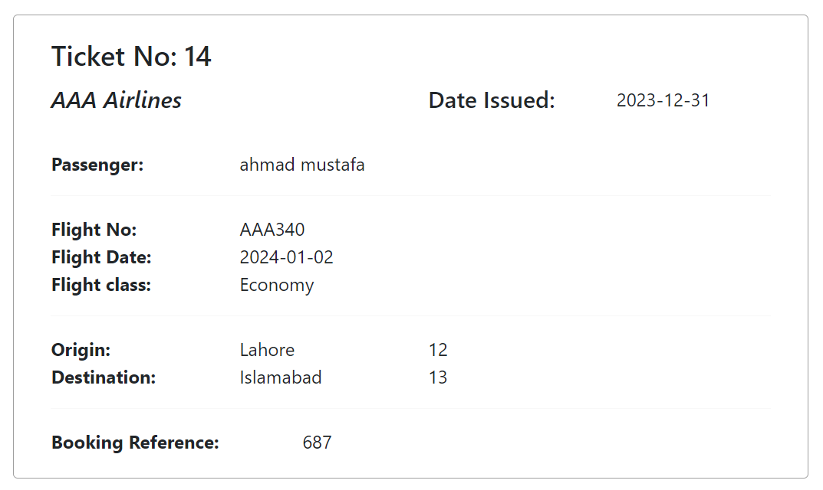

**C) Manage Booking:**

1. **Enter last name & booking reference:**

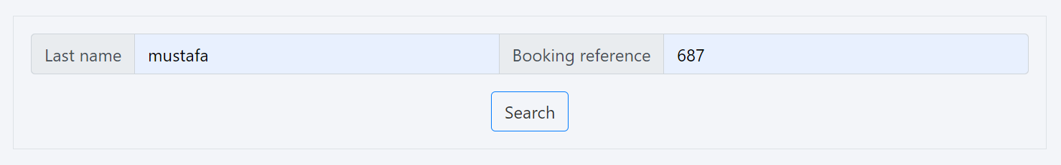

1. **Update booking:**

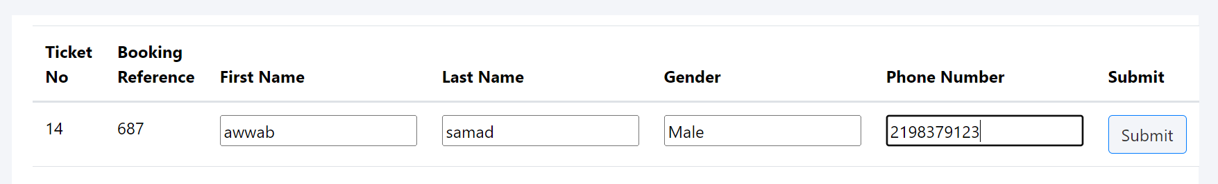

1. **Get updated ticket:**

**D) View Today’s Flights:**

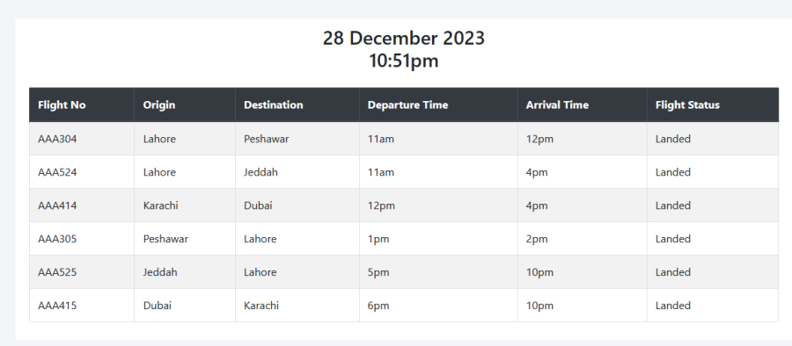

**E) Admin Panel:**

**1. Login with admin password (admin123):**

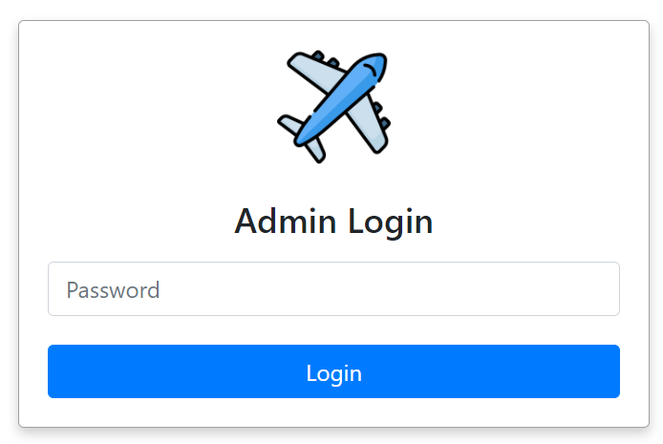

1. **View flights with sorting filters:**

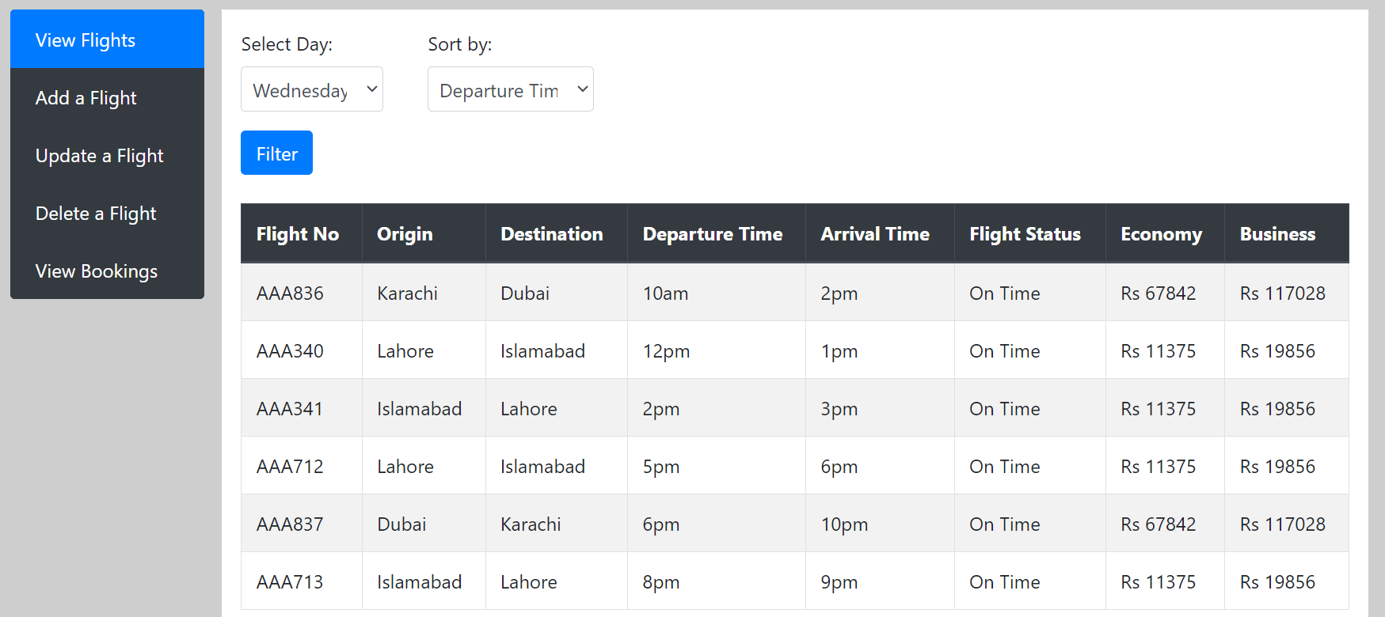

1. **Add a new flight:**

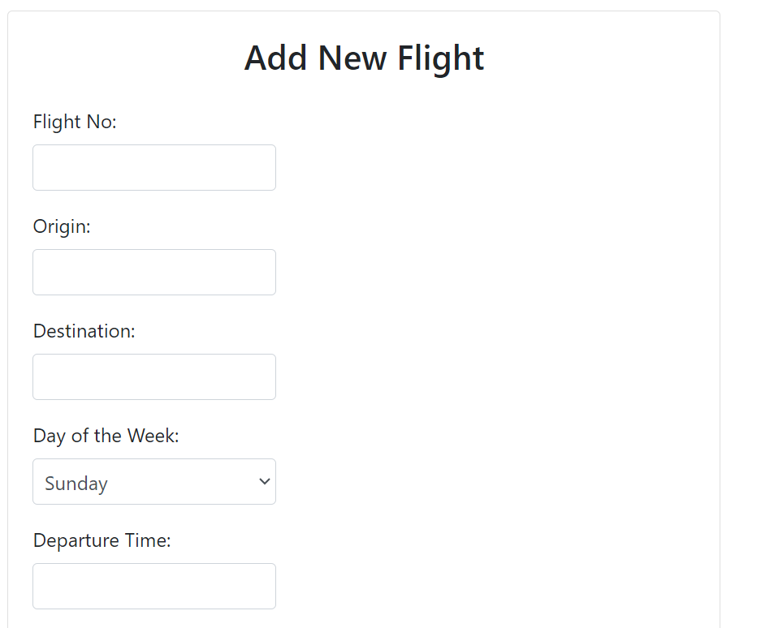

1. **Update a flight:**

1. **Delete a flight:**

1. **View all bookings with sort filters:**

**Database Schema:**

**ER Diagram:**

